Dr. Marlena E. McKnight
Associate Partner Strategy/ Research
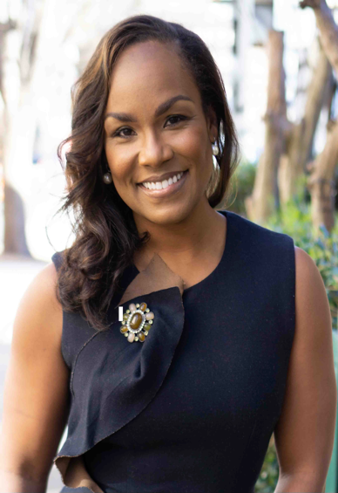
Dr. McKnight is an experienced educator with a skillful passion for making visible the needs of historically underrepresented and systematically marginalized communities.

She currently serves as Associate Partner for Strategy and Research at MJR Partners, a national arts management consulting firm with offices in Dallas, New York and Atlanta; and is Advisor for Contemporary Curriculum Development to the College of Business & Entrepreneurship at Bethune-Cookman University in Daytona Beach, Florida.

Her areas of focus include investigating client needs, developing data driven professional development and guiding systemic change management through the lens of racial equity and inclusion. With over 15 years of experience in the field of education and literacy across the lifespan, McKnight has consistently advocated for disrupting practices that get in the way of equitable service delivery in the education and the non-profit arts sectors. She has been on the MJR Partners Team for 6 years, providing expertise in research, curriculum development and inquiry-based approaches to building cultural competencies for professional staff teams.

McKnight received a B.A. from Wake Forest University, a Master of Arts in Teaching from American University in Washington, D. C., and a Ed.D from the University of Pennsylvania where she served as Associate Director of The Black Cultural Center. At UPENN she taught both undergraduate and graduate level courses in the Africana Studies Department and in the Graduate School of Education. Her most recent consulting work with MJR Partners has focused on Diversity and Inclusion training for local arts agencies including the cities of Columbia, South Carolina, Austin, Texas, San Diego, California and the Missouri State Arts Council.

