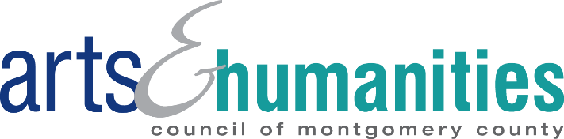
FY24 Wheaton Cultural Project Grants (WCPG)
Partner Organization Letter of Support
Name of FY24 WCPG Artist/Scholar Applicant:
Name of Partner Organization:
Project Start Date:
Project End Date:
(Projects must take place between January 1, 2024 and December 31, 2024)
Briefly describe the role of the partner organization in collaborating with the applicant artist/scholar to ensure that the project is successfully implemented, including how the partnership will enhance the applicant’s work and benefit the Wheaton community. (Examples of support may include assisting with community outreach, publicity and marketing, providing volunteers, providing space and/or supplies, providing technical support etc. This is not an exhaustive list.)

By signing below, (insert partner organization name) understands that if an FY24 Wheaton Cultural Project Grant (WCPG) is awarded to (insert applicant artist/scholar name), the applicant artist/scholar and partner organization must comply with all Arts & Humanities Council of Montgomery County FY24 WCPG grant requirements throughout the duration of the grant period. A full list of FY24 WCPG requirements can be found in the guidelines at https://www.creativemoco.com/grant/wheaton-cultural-grants/#GuidelinesEligibility.
Partner Organization Representative:
Signature: ____________________________________
Printed Name: _________________________________
Title: _________________________ Date: __________

